Assignment Report

By Sanjay Gohel

1 ) Project Starts with Login page

* First and Foremost is User need to Login in System for doing any task

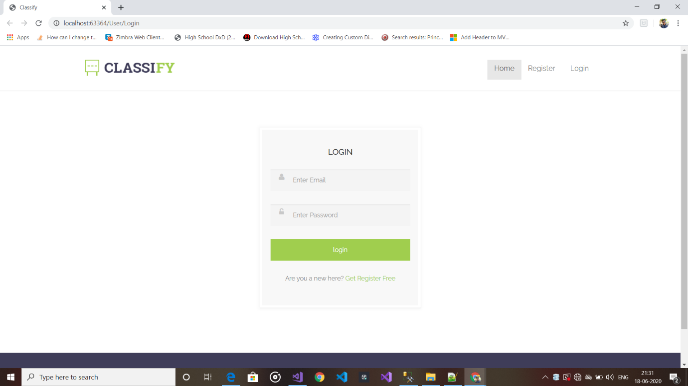

* 1. Login Page

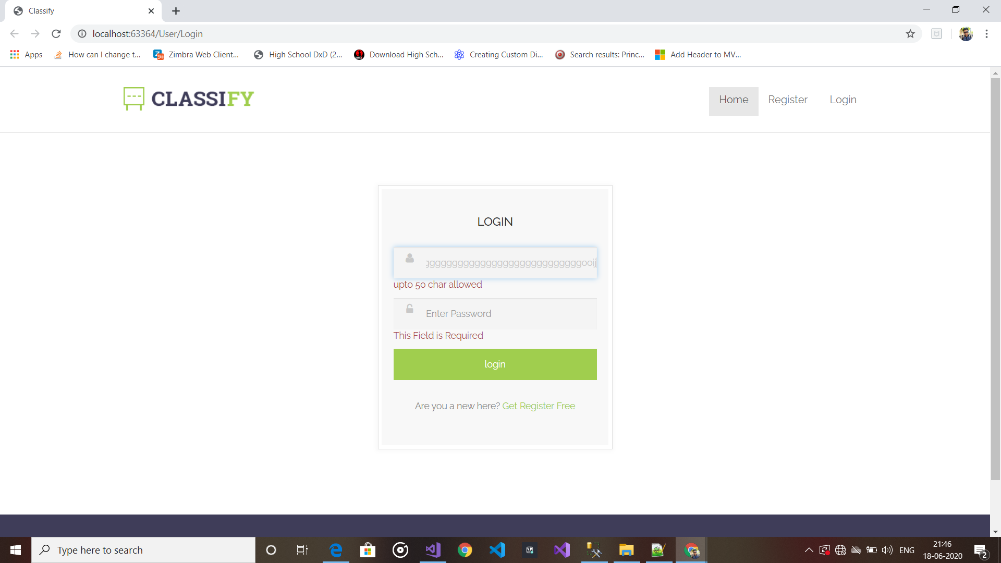

1.2)Validate login page

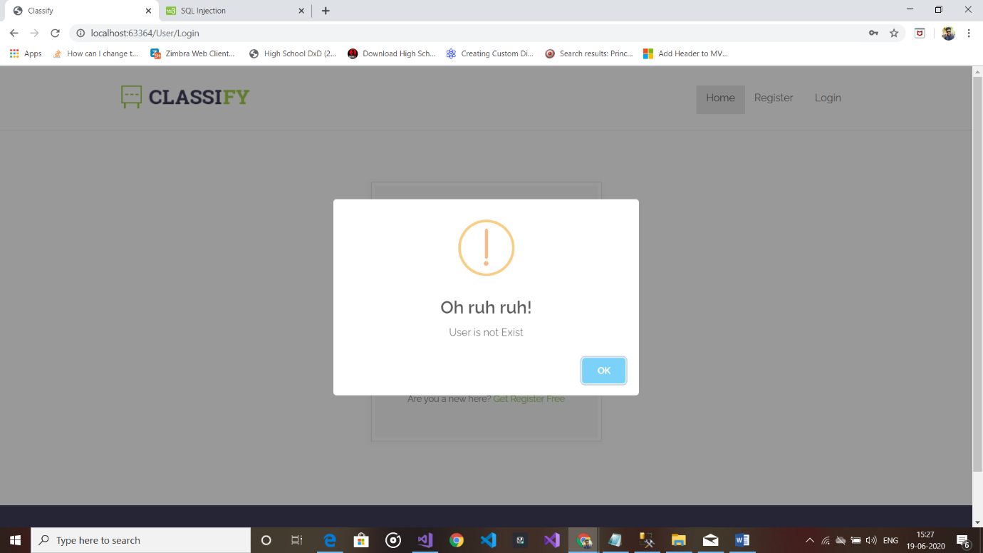

1.3)Validation if User is not Exist

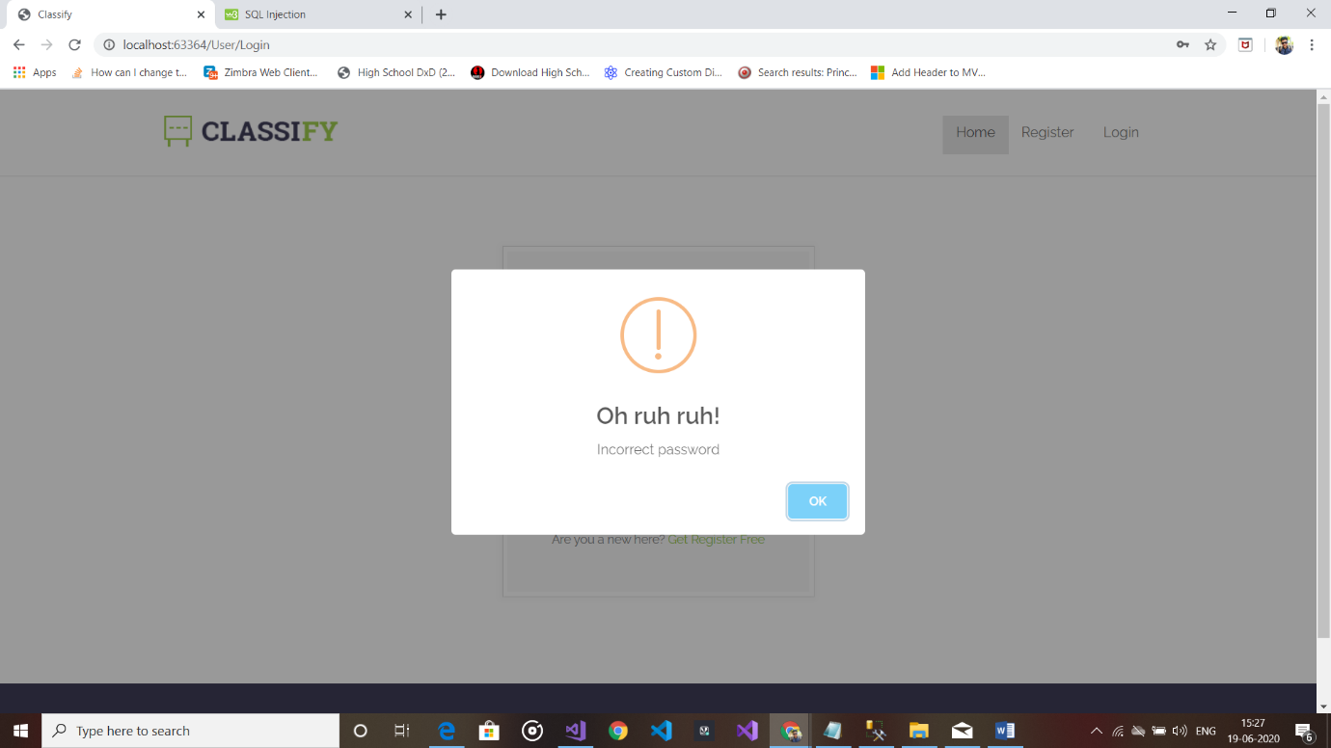

1.4)User Exist But Enter incorrect password

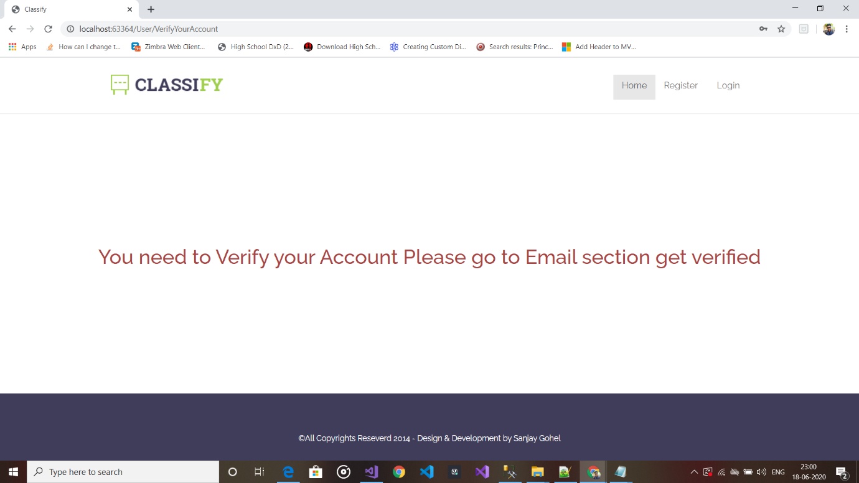

1.5)User Is Valid But not active and verified

2)Registration Page

* If User don’t Have account they can register them self into system.
* After Registration User Receive on link in mail
* After clicking on link user get verified and then they can proceed to login

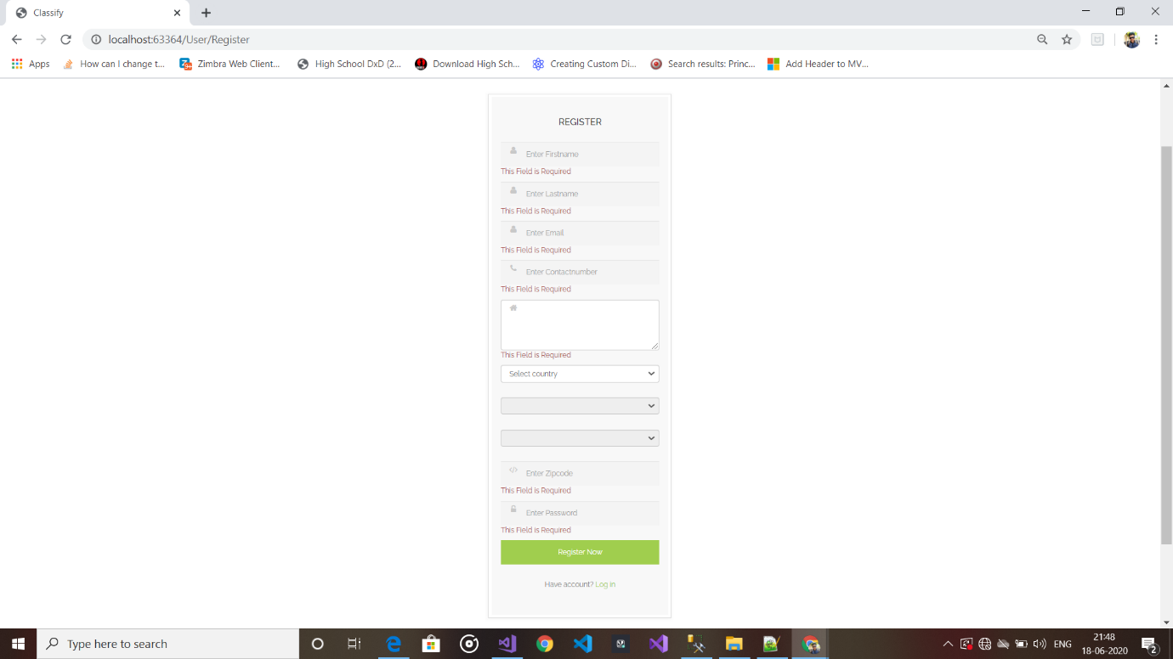

2.1)Registration Form with validations

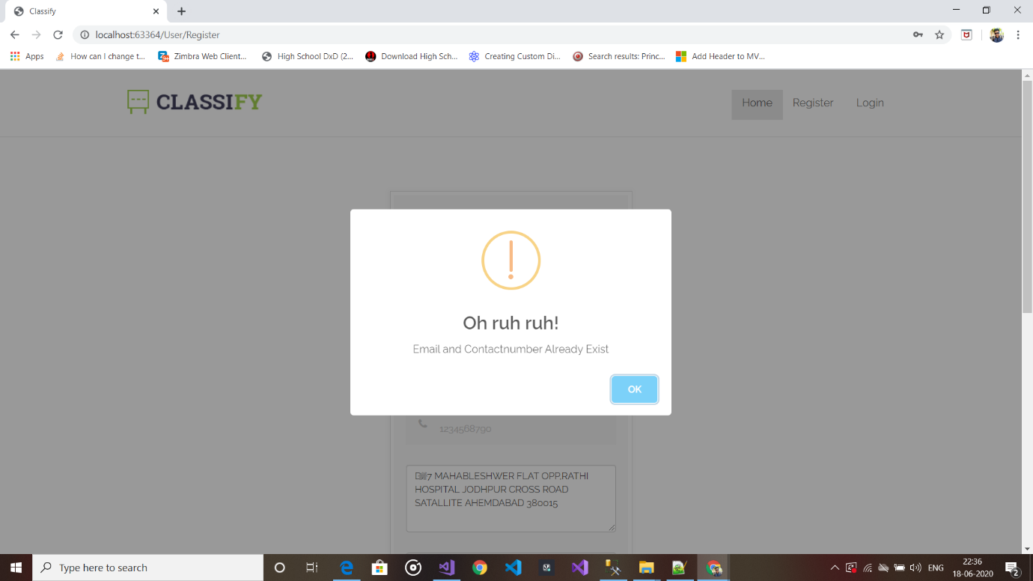

2.2) Check if User is already exist in database

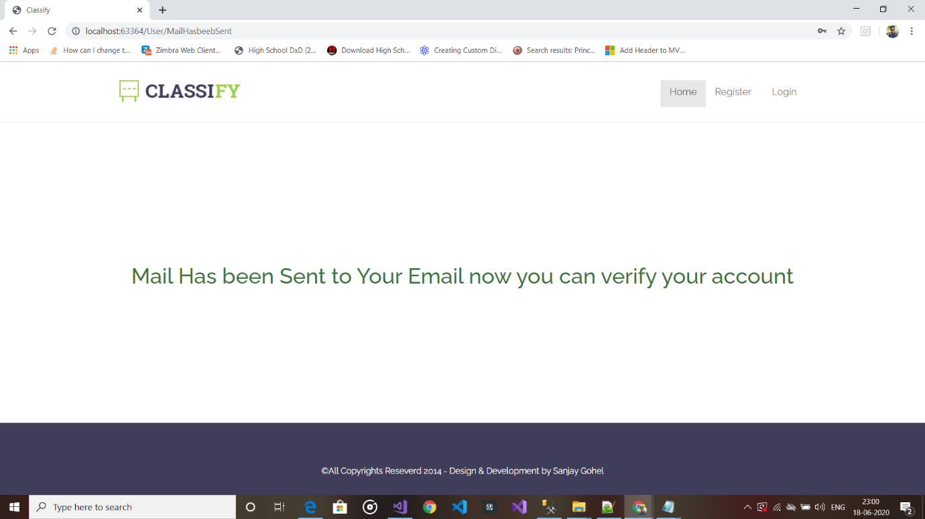

2.2)Acknowledgement after Successful Registration

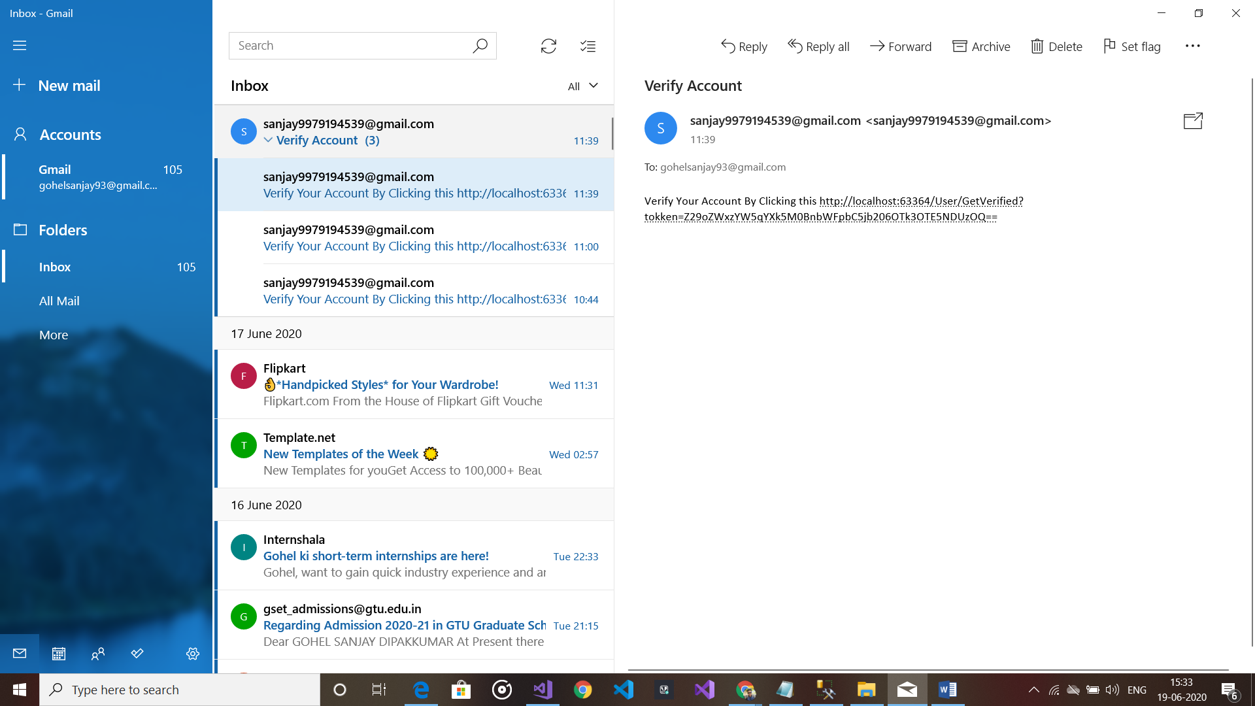

2.3) User receive Link in mail after registration

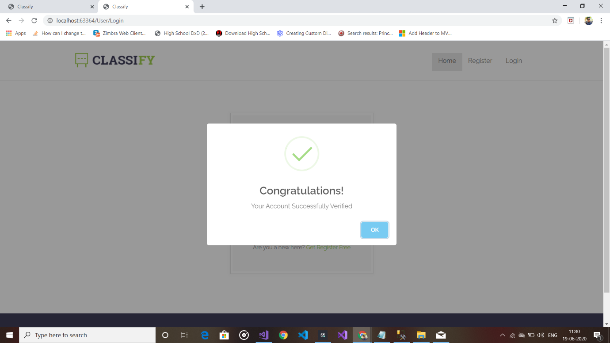

2.4) After Clicking on link User get verified and redirected to login page

3)Home page

* After Finishing with Register and Login then finally landing in Home page
* It Contains First Category Details
* It Contains Products and on Hover products we can see two controls first Edit and second Delete
* On top Corner we can see users name

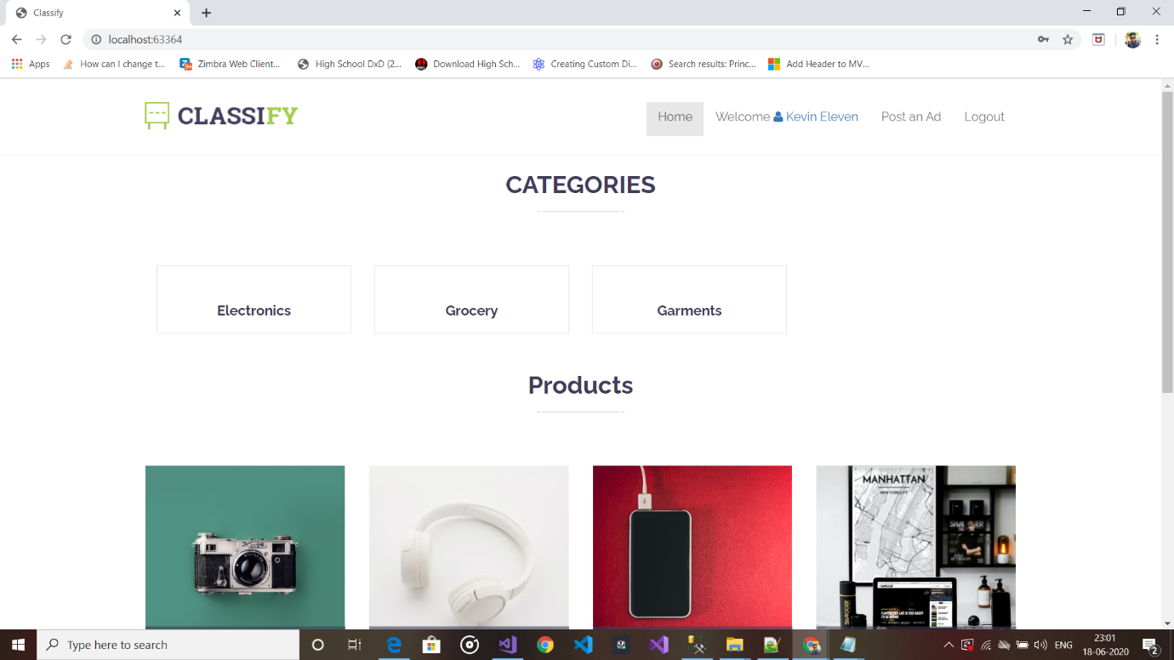

3.1)Home page(Landing page)

**4)Product Add**

* In Product add page we can select Category and Image rest is inputs.
* So in image file validation is like it should be image file like jpg ,jpeg or png and Size of image should not be more than 1 mb.

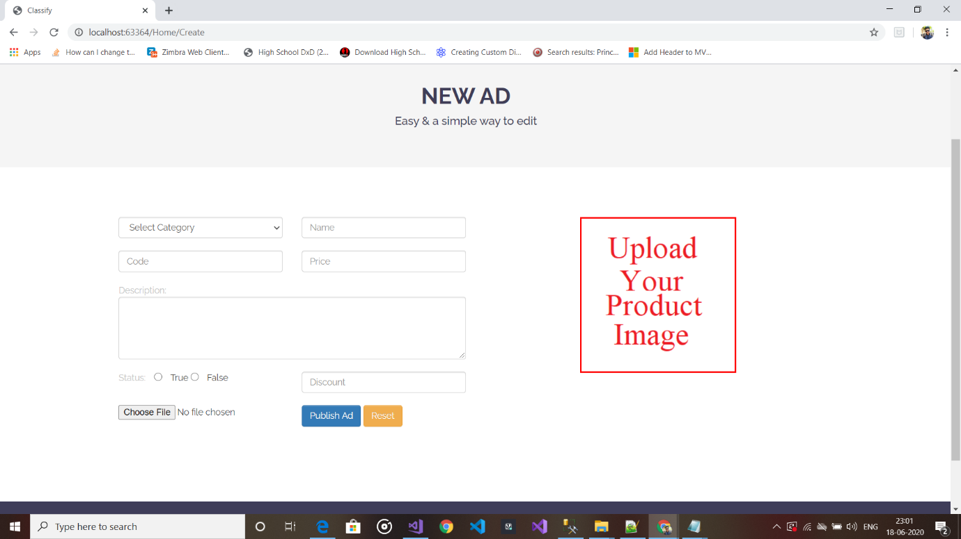

4.1)Add Product page

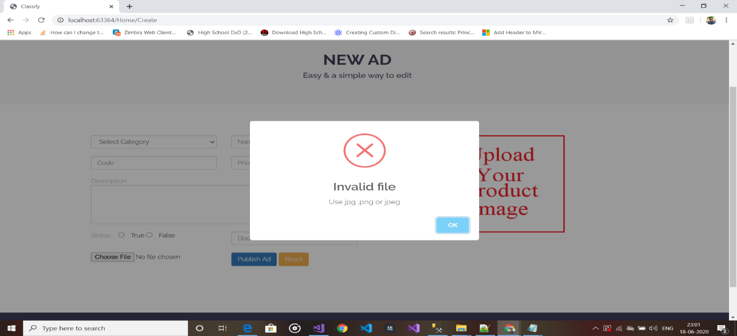

4.2)Invalid file validation

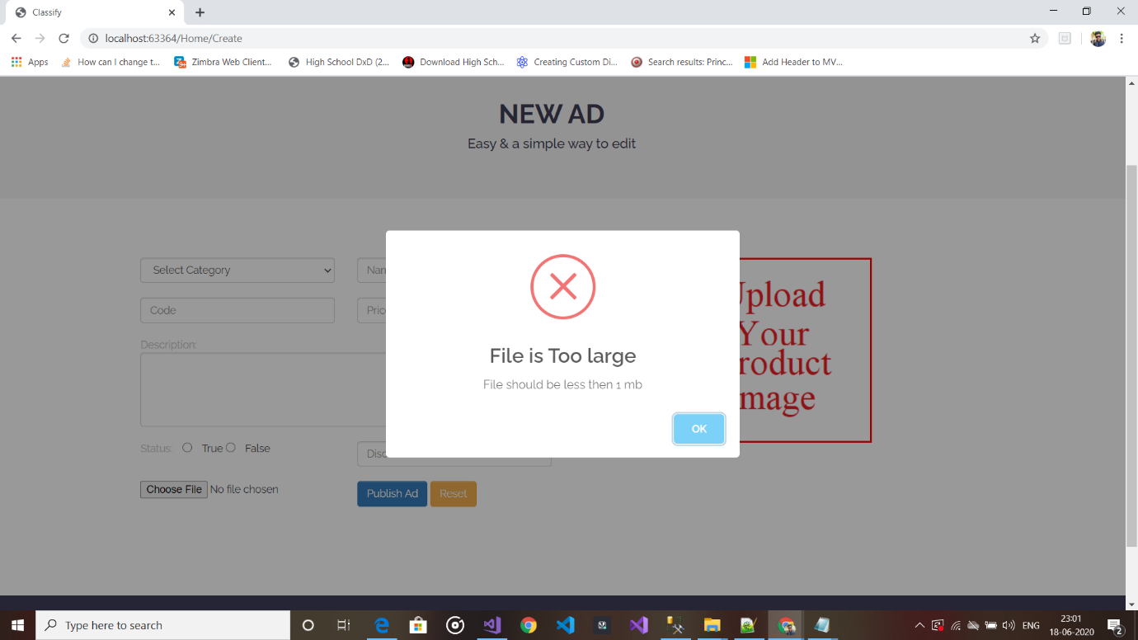

4.3)File is too large validations

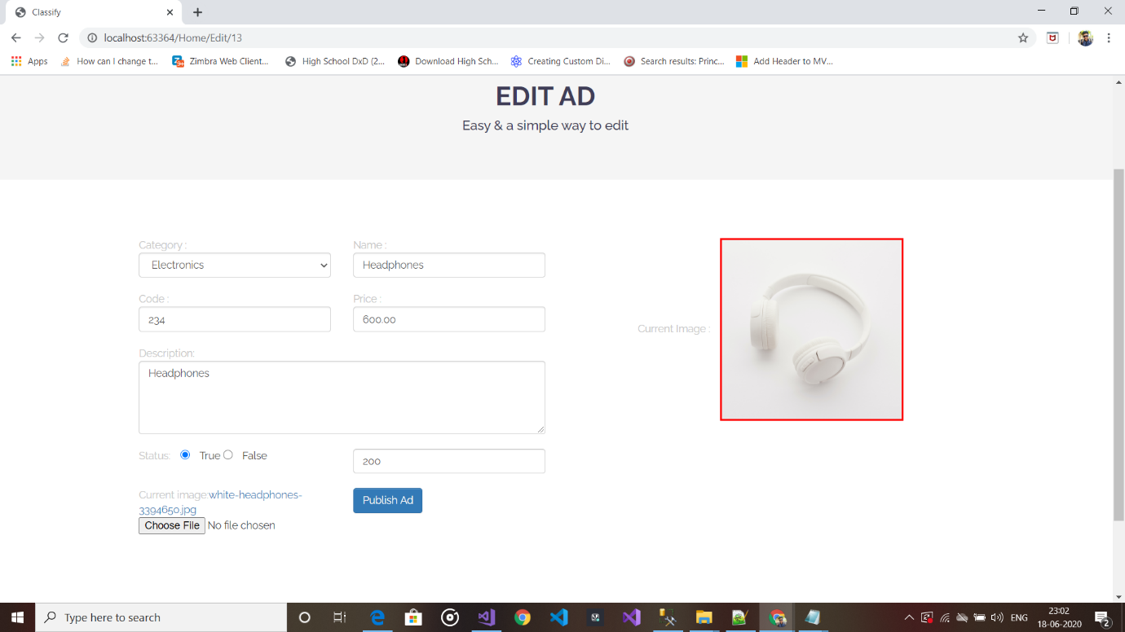

4.4)Preview Image before Upload

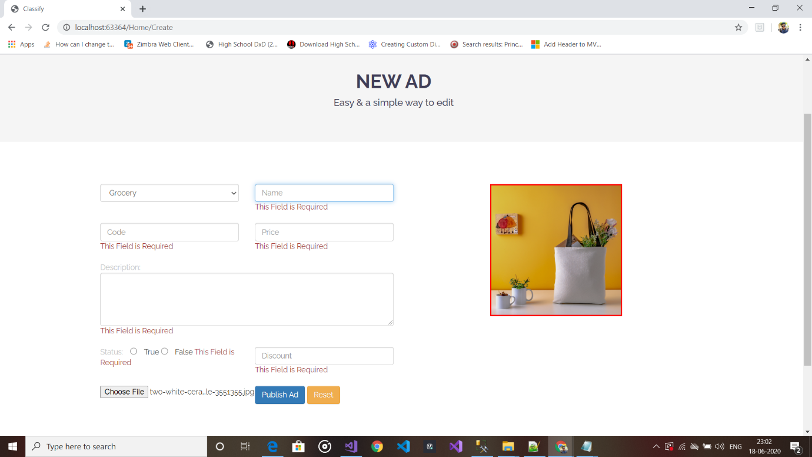

4.5)Validation Product add form

5)Edit Product Details

* After Adding Product if user wants then they can edit data of product by clicking on edit button.
* Here If user leave file blank than it will not change.



5.1)Edit Product

**6)Delete Product**

* Delete Product done by post id
* Before delete product it ask to user for confirmation
* I have Also Added Multiple delete Option but it is not visible here because it is on hover process
* Also have validations of selected product if user directly click multiple delete button it will show alert box.

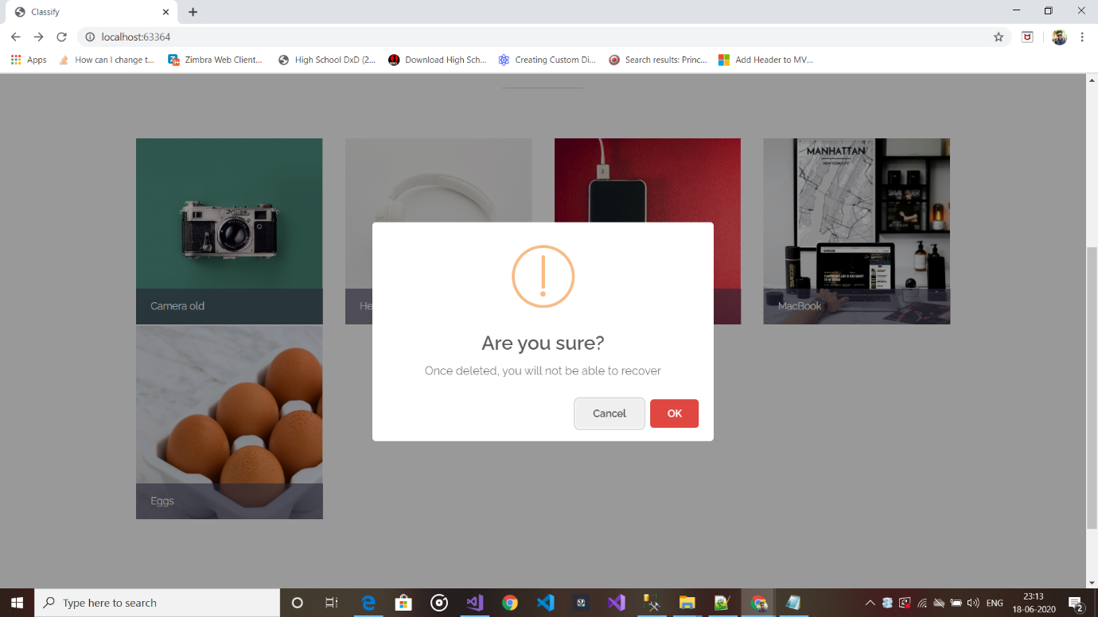

6.1)Confirm Delete

**7) Users Details**

* By clicking on User name from top right corner user lands on Profile page

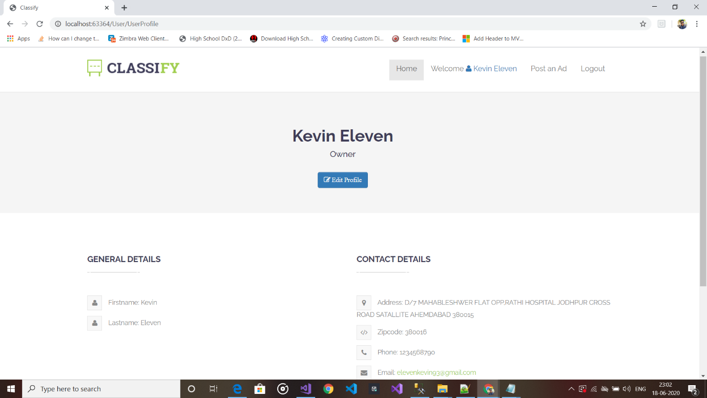

7.1)User Profile

**8)Edit Profile**

* Here I have only work with changeable data because we can’t user let change some important data every time like email ,password and contact number.
* Additionally I have created Chain dropdown in which user must select country before select state and user must select state before select city.
* Based on user choose dropdown fill automatically.

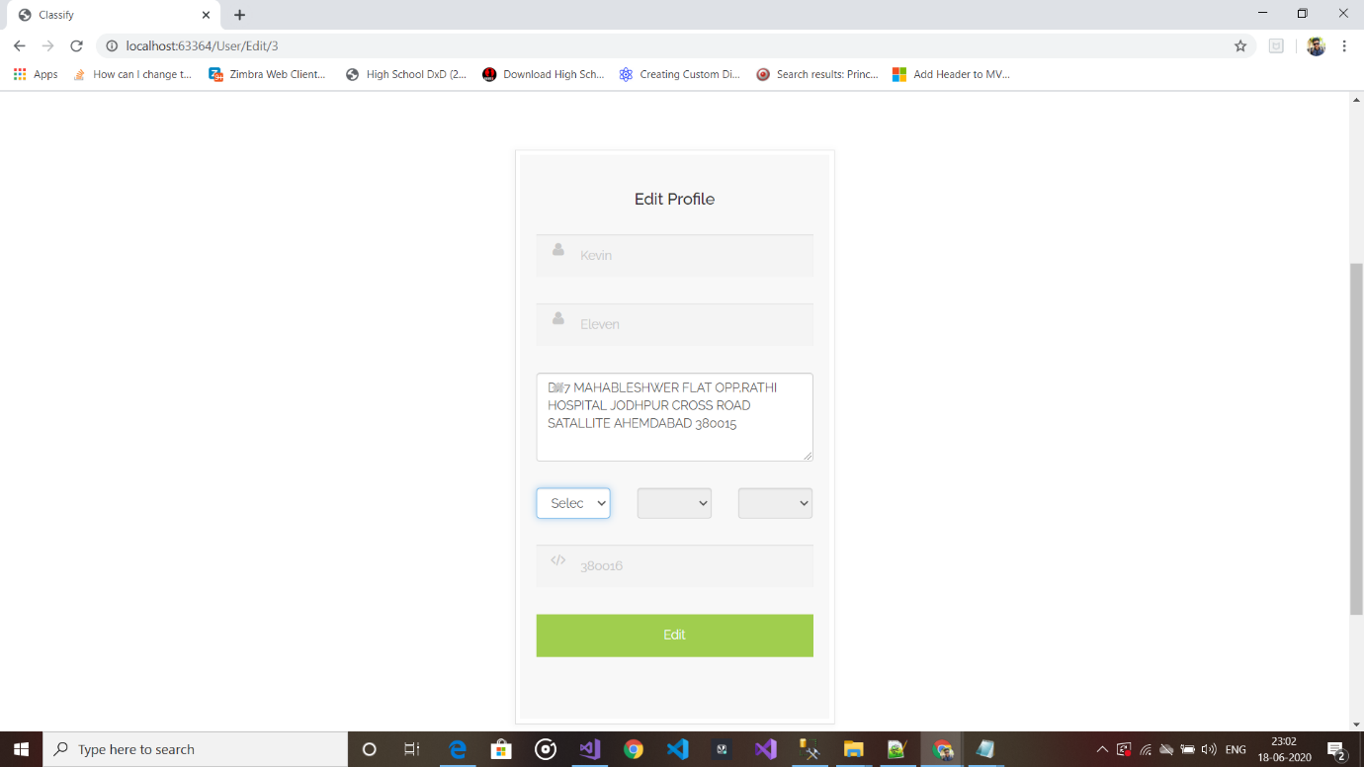

8.1)By Clicking Edit User can edit Profile data

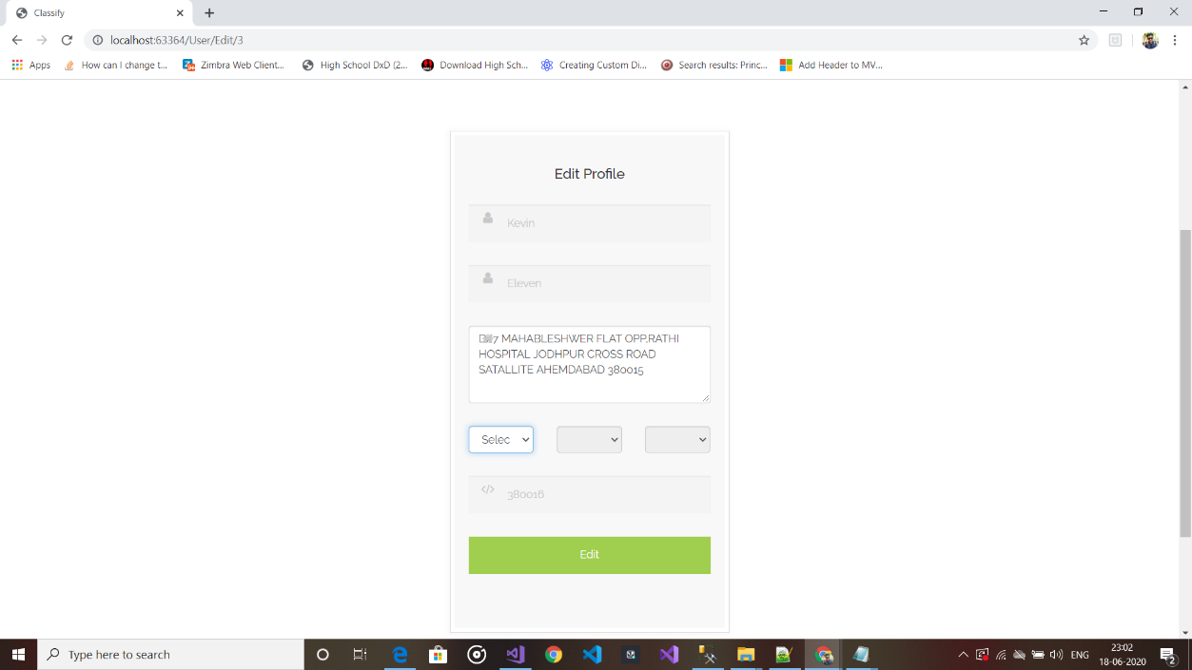

8.2)Selected Country

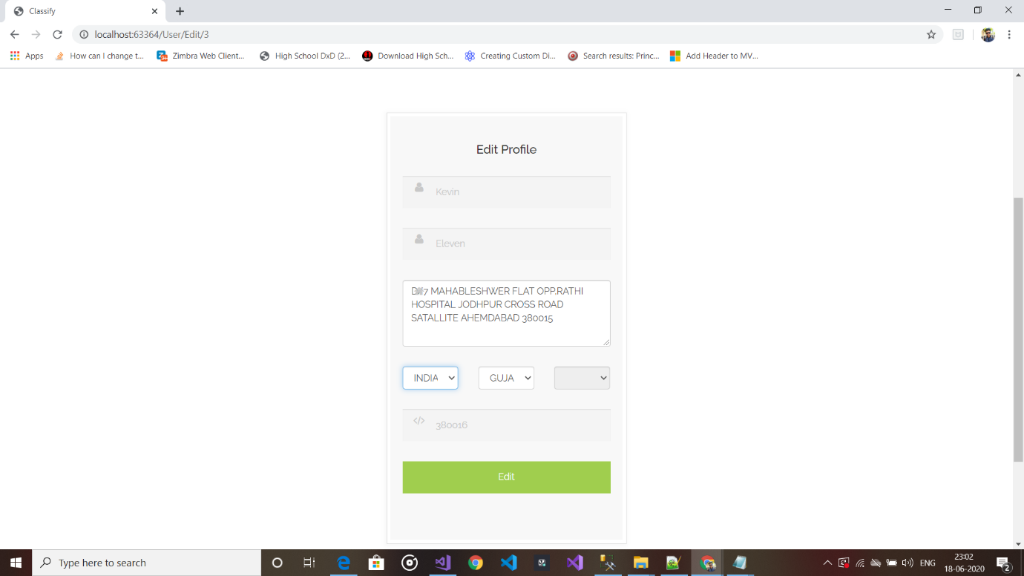

8.3)Select State

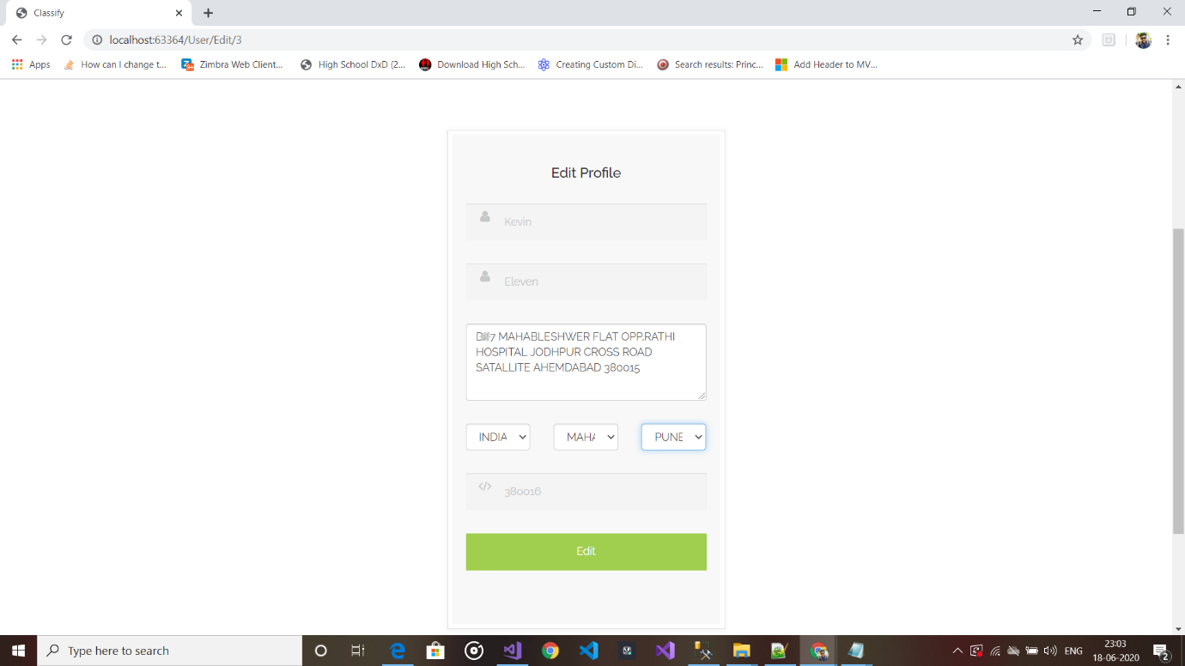

8.4)Select City

**9)Acknowledgements after operations**

* I have used sweet alert for make prompt box more attractive

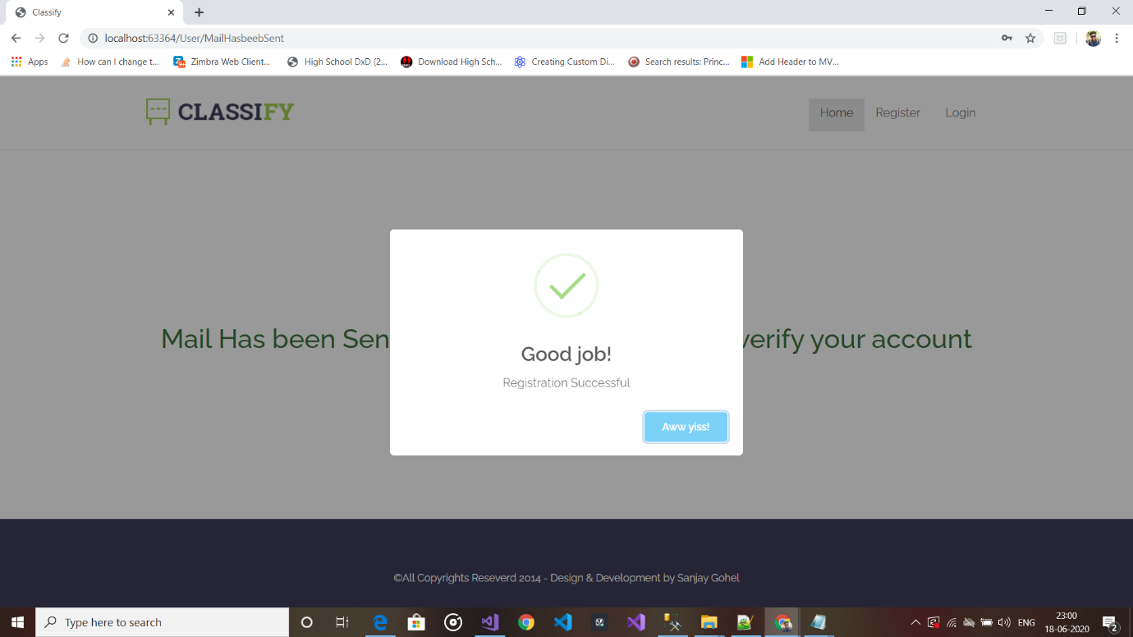

9.1)Success alert



9.2)Warning alert



9.3)Error alert

10)Error Log file

* I have create custom Error log file which is lock the exception in text file.
* Also Created Custom Error page for not show danger yellow page.

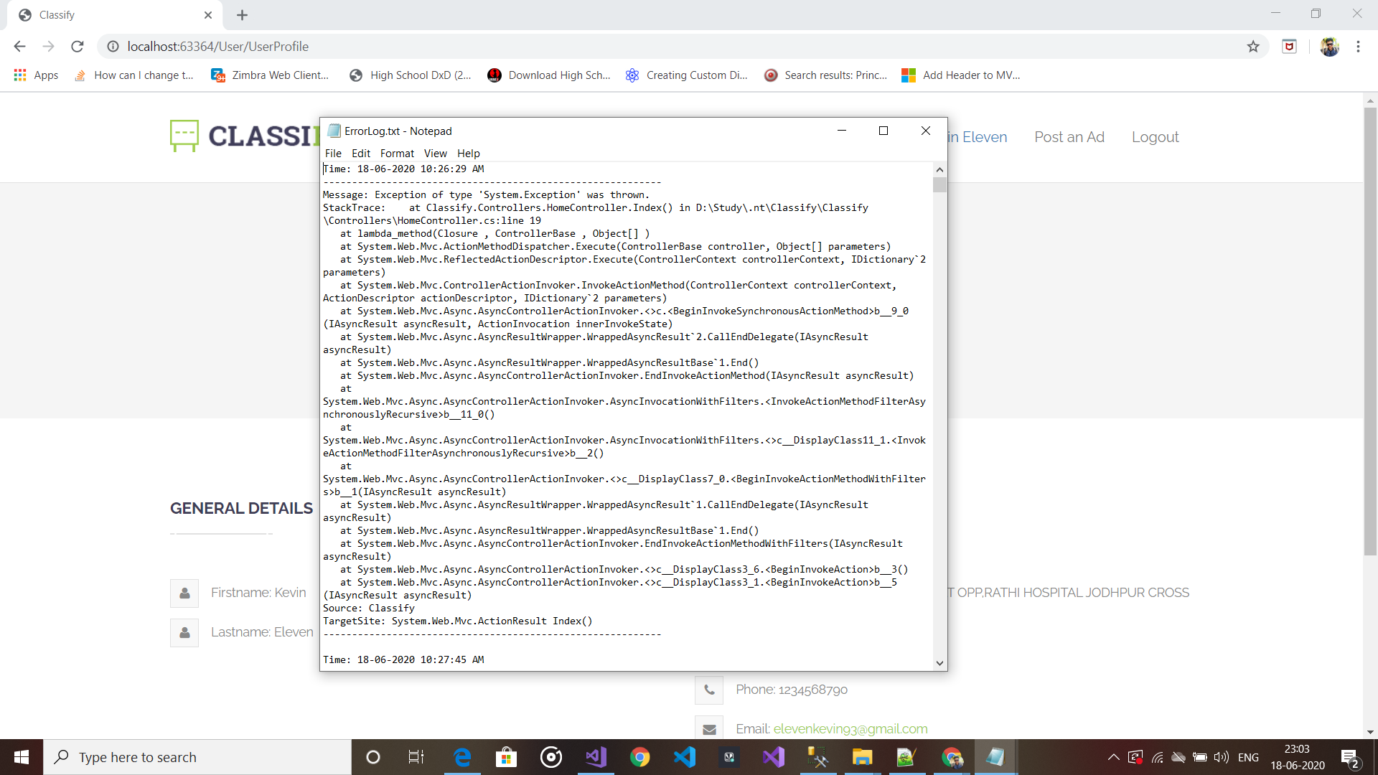

10.1)Errorlog.txt

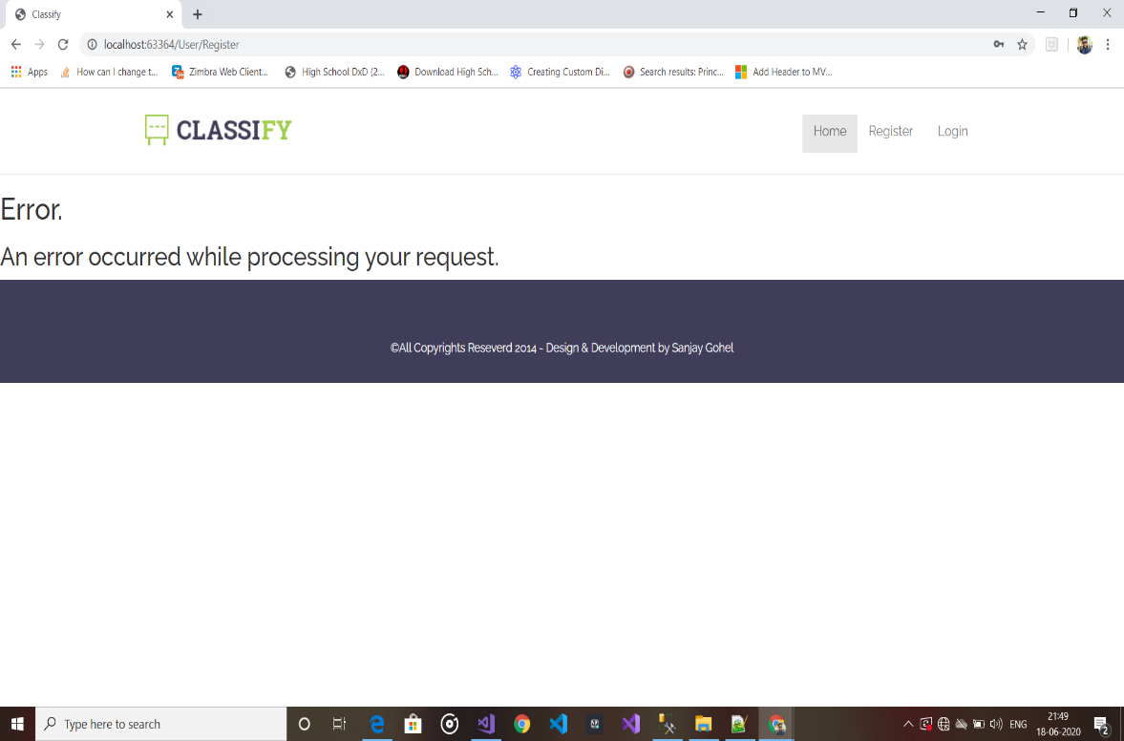

10.2)Custom Error page